**Cambridge Digital Galvanometer:**

* **DC2000**
  + Features
    - 16-bit DAC.
    - Self-Tuning
    - DSP based control
    - Lattice FPGA
    - Bridge Amplifier Output for Full Galvo Small and Large Angle Speed
    - XY2-100 or High Speed Serial Digital Input Command
    - 1 minute warm up period
  + Spec
    - Command Input: XY2-100 / High Speed Serial Digital
    - Analog Output Impedance: un-terminated output of OPA2227, <1Ohm
    - Position Output Scale Factor: 0.333V/degree non-differential
    - Power Supply: +/-15 to +/-32V DC
    - Max Drive Current Limit: 10A peak, 2.5A rms Per Axis (power supply and load dependent)
    - Operating Temperature Range: 0~50°C
    - Size: Base Board 8.6cmx6.14cmx2.7cm, 2nd Axis Amplifier 8.6cm x 3.43cmx2.25cm

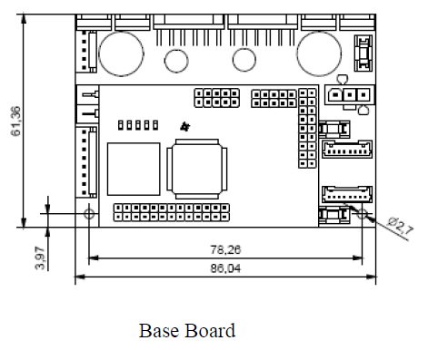

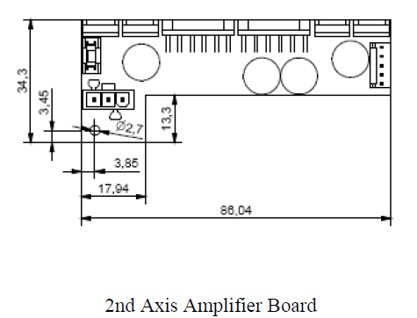

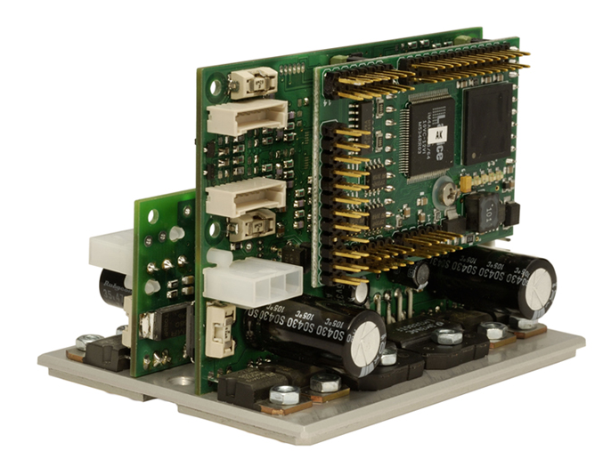

**Shenzhen Galvo-Tech**

* G-serials
  + 18-bit AD

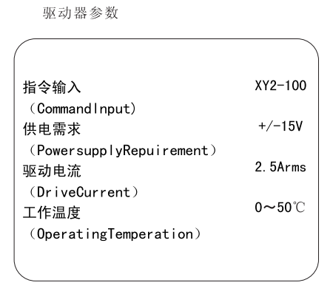

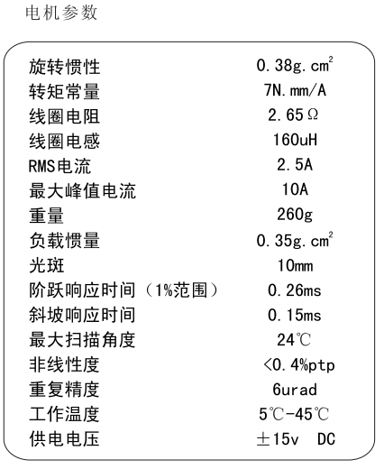

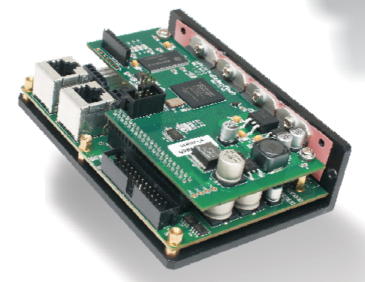

**Articles**

* 数字式振镜控制系统的研究 (TMS320F28335 based)

<http://www.doc88.com/p-1186525131077.html>

* 基于DSP的高速高精度振镜标记机控制系统研究 (TMS320C6205 based)

<http://www.docin.com/p-163422554.html>